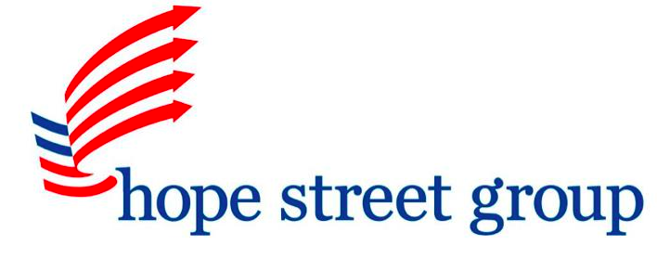

PRESS RELEASE

DE Educator Named Hope Street Group National Teacher Fellow

Melissa Tracy, of Conrad Schools of Science in Wilmington, DE, will spend 2014 advocating for the elevation of the teaching profession

FOR IMMEDIATE RELEASE

Press Contact:
Maureena Thompson
Senior Associate, Outreach & Communications
(805) 748-2272
maureena@hopestreetgroup.org

January 14, 2014 – (Washington, DC) – Melissa Tracy, a Social Studies Teacher at Conrad Schools of Science in Wilmington, has been selected as a Hope Street Group 2014 National Teacher Fellow. She is one of only 13 educators nationwide to be invited to participate in this fellowship program and is this year’s representative from Delaware.

The National Teacher Fellowship program provides fellows, who are either classroom teachers or instructional coaches, with rigorous training, opportunity to network with teachers across the country, and participation in national conversations. Past fellows have written op-eds for major news publications, participated in state and national-level discussions with policymakers on education initiatives, and developed recommendations and solutions for enhancing teacher effectiveness systems as well as college and career ready standards implementation, as outlined in the Teacher Evaluation Playbook.

“Teachers are some of the best experts in educational policy and we have a responsibility to advocate for all students,” said Tracy. “I am part of the Hope Street Group Fellowship because I desire to learn about educational policy at the national level, to develop my skill set, and to positively impact all students.”

In addition to her work at Conrad Schools of Science, Tracy teaches A.P. Human Geography to high school students via a distance-learning lab, acts as a Model UN Coordinator for 50 middle school and high school students, and serves as a member of the Rodel Teacher Council. Tracy holds a Master of Education degree in Social Studies Curriculum and Instruction from the University of Delaware and is currently a James Madison Fellow, pursuing an M.A. in History at Villanova University.

Hope Street Group, a national nonpartisan, nonprofit organization dedicated to expanding economic opportunity and prosperity for all Americans, sponsors the fellowship as part of its larger Education program, which seeks to transform the teaching profession to improve outcomes for students.

Dan Cruce, Vice President of Education, Hope Street Group said, “Hope Street Group’s National Teacher Fellows Program provides educators the training, support and tools they need to connect policymaker goals with on the ground expertise. With improved educator effectiveness systems, implementation of rigorous college and career ready standards, and the need for better professional learning, such teacher voice input has never been more important. Our National Fellows stand ready to meet this need, partner with policy makers and drive collaborative decisions in the best interest of our students.”

# # #

Hope Street Group is a national nonprofit, nonpartisan organization dedicated to expanding economic opportunity and prosperity for all Americans. Founded by a small group of young entrepreneurs on South Hope Street in Los Angeles, we are committed to helping further innovative and collaborative reform efforts in education, health and jobs and workforce. www.hopestreetgroup.org

